## **Final Project Report: Visualizing the Relationship Between Atmospheric CO₂ Levels and Extreme Weather Events**

Team members: Rabin, Farhan, Danrong

#### 

*Figure 1. Mind Map of the Final Project Report on the Relationship Between CO₂ Levels and Extreme Weather Events.*

This mind map provides an overview of the key components of the research proposal, including the background and motivation, research questions, application scenarios, methodology, anticipated results, and intellectual merit and practical impacts. It highlights the integration of interdisciplinary approaches and data sources to address the global implications of climate change through advanced data visualization techniques.

**1. Background and Motivation**

Climate change, driven by rising levels of carbon dioxide (CO₂) in the atmosphere, has led to more frequent and severe extreme weather events such as floods, droughts, and storms. Understanding and visualizing the relationship between these phenomena can help policymakers, researchers, and the public make informed decisions to mitigate the impacts of climate change. Data visualization provides a powerful tool to reveal trends, anomalies, and patterns in climate data that may not be immediately obvious through traditional analysis.

Previous studies have explored the impact of CO₂ on climate patterns, but the use of interactive visualizations to explore this relationship remains limited. Unlike prior studies that focus on localized datasets or static visualizations, this project integrates global datasets from NASA, NOAA, and EM-DAT, offering a dynamic and interactive visualization approach to better understand the global relationship between CO₂ levels and extreme weather events.

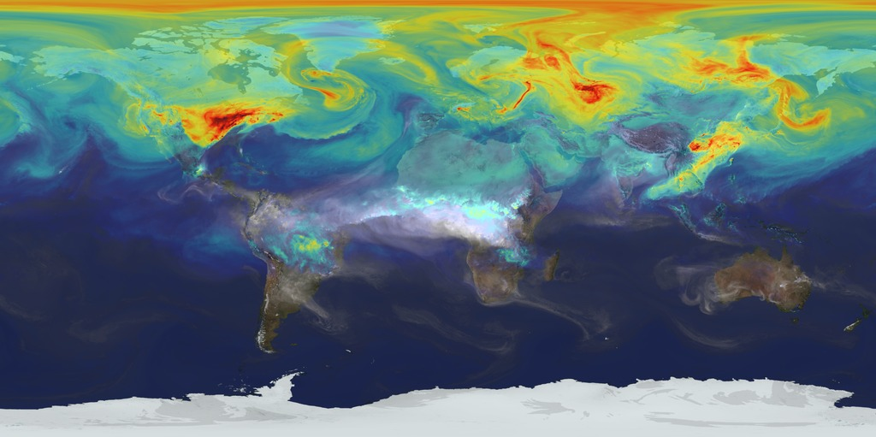

*Figure 2. Inspiration for our project: Global Atmospheric CO₂ Visualization.*

This image, created by NASA's Goddard Space Flight Center, shows the global distribution and movement of atmospheric carbon dioxide (CO₂) over a year. The colors represent varying concentrations of CO₂, with red indicating higher levels and blue indicating lower levels.

## 

## 

## **Explanation of Connection to Research Goals:**

This visualization inspired our project as it effectively communicates the spatial and temporal dynamics of CO₂ emissions. By using similar principles of data visualization, our project aims to explore and present the relationship between rising atmospheric CO₂ levels and the frequency of extreme weather events like floods and droughts. The use of clear, color-coded visualizations helps make complex climate data accessible to a broader audience, supporting informed decision-making and public awareness.

#### 

#### 

#### **2. Research Questions**

This research will focus on the following key questions:

* How have atmospheric CO₂ levels changed over the past few decades?
* What trends or correlations exist between CO₂ levels and extreme weather events like floods, droughts, and hurricanes?
* How can data visualization techniques uncover patterns that traditional statistical
* methods may miss?

By answering these questions, the study aims to contribute to the broader understanding of climate change and its global implications, utilizing data visualization to provide more intuitive and actionable insights.

#### **3. Application Scenarios**

Real-World Applications:

1. Climate Science:  
    Understanding the relationship between CO₂ levels and extreme weather events can enhance climate models, improving predictions and preparedness. Organizations like the [Climate Prediction Center](https://www.cpc.ncep.noaa.gov/) provide climate forecasts and monitoring that can benefit from such insights. https://www.cpc.ncep.noaa.gov/
2. Disaster Management:  
    Real-time visualizations assist agencies in assessing risk-prone areas and planning effective interventions. The [Federal Emergency Management Agency (FEMA)](https://www.fema.gov/) leads federal response efforts and could utilize these visual tools for better resource allocation. https://www.fema.gov/
3. Policy and Education:  
    Interactive visualizations serve as educational tools, raising awareness among policymakers and the public about the links between CO₂ emissions and climate-related disasters. Initiatives like the [Climate Education Coalition](https://www.earthday.org/climate-education-coalition/) aim to integrate climate education into curricula worldwide, promoting informed decision-making. <https://www.earthday.org/climate-education-coalition/>

#### 

#### **4. Methodology**

The methodology for this research involves the following steps:

* **Data Sources and Integration**:
  + **NASA's Earth Observing System Data and Information System (EOSDIS)** provides satellite-based data on CO₂ levels (NASA, 2023).
  + **NOAA's National Centers for Environmental Information (NCEI)** will be used to obtain data on extreme weather events such as floods, droughts, and hurricanes (NOAA, 2023).
  + **EM-DAT, The International Disaster Database**, offers data on the occurrence and impacts of global disasters (CRED, 2023).
* **Integration**: Combining these datasets to offer comprehensive insights not achievable with single data sources.
* **Visualization Techniques**:

1. A (**time-series plot)** will be used for now to show the relationship between CO₂ concentrations and extreme weather events over time from 1959 to 2023.

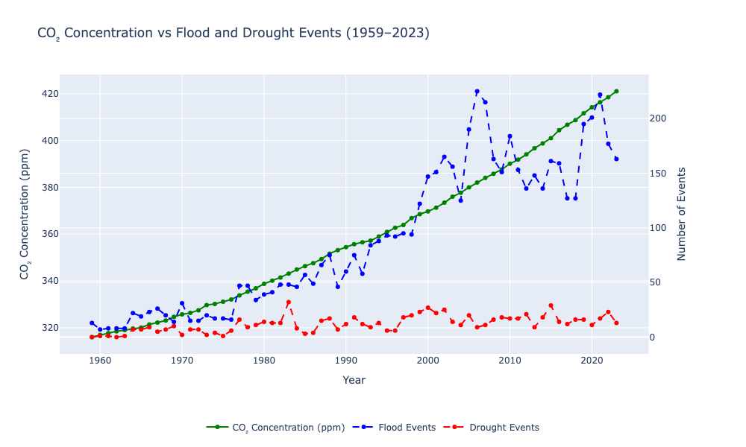

*Figure 3. Trends Between Atmospheric CO₂ Concentration and the Frequency of Flood and Drought Events (1959–2023)*

This plot illustrates the trends in atmospheric CO₂ concentration (measured in parts per million, ppm) alongside the frequency of flood and drought events over time. The green line shows the consistent rise in CO₂ levels, while the blue and red lines represent the yearly counts of flood and drought events, respectively. The visualization highlights a potential relationship between increasing CO₂ levels and the occurrence of extreme weather events, particularly floods.

1. Choropleth Maps

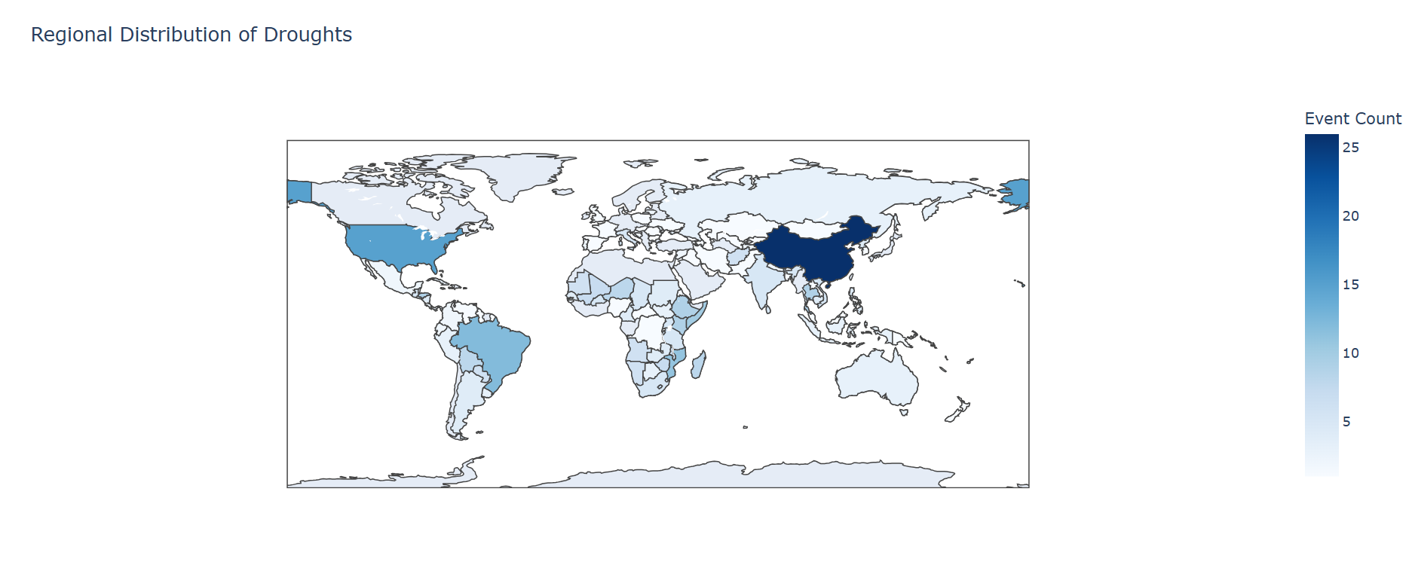

*Figure 4. Regional Distribution of Droughts.*

This choropleth map visualizes the frequency of drought occurrences globally, with varying shades of blue representing the intensity of drought events. Darker shades indicate regions with a higher number of drought events, highlighting areas most affected by water scarcity and climate variability.

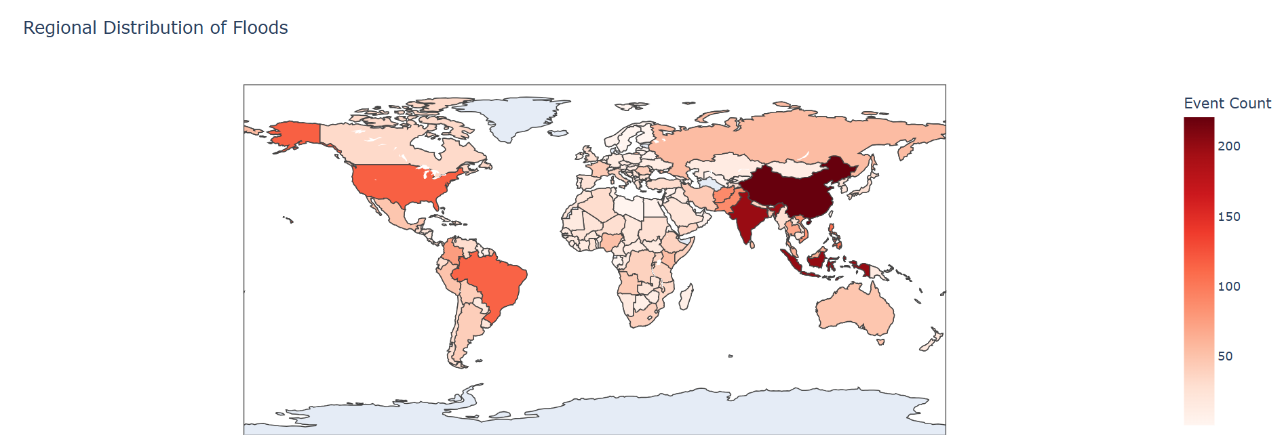

#### *Figure 5. Regional Distribution of Floods.*

#### This choropleth map displays the distribution of flood events by region, utilizing ISO country codes for location identification. The map uses a red color scale, where deeper shades represent a higher number of flood events.

## **Tools**: We used Python libraries such as Matplotlib, Plotly, and Dash for creating interactive visualizations.

#### 

#### **5. Results**

We anticipate discovering several key insights:

* A clear temporal correlation between rising CO₂ levels and an increase in the frequency and severity of extreme weather events.
* Regional variations in the impact of CO₂ on extreme weather, with some areas experiencing more pronounced effects.
* The effectiveness of interactive visualizations in communicating these complex relationships to a non-expert audience.

#### 

#### **6. Intellectual Merit and Practical Impacts**

Academic Contribution:

This research contributes significantly to the academic field of data visualization by integrating interdisciplinary datasets and employing advanced visualization techniques to address climate change issues. Specifically:

* Innovative Use of Data Visualization: By combining datasets on atmospheric CO₂ levels and extreme weather events, the research demonstrates how interactive visualizations can uncover patterns and correlations that static methods or traditional statistical analysis might miss.
* Methodological Advancement: The project showcases the application of state-of-the-art visualization methods, such as time-series plots and dynamic spatial maps, which are tailored to reveal temporal and regional variations in climate phenomena. This contributes to the ongoing evolution of visualization techniques and their application in environmental studies.
* Cross-Disciplinary Insights: The study bridges climate science, data visualization, and public policy, offering a new perspective on how visual tools can inform and influence multiple domains. This cross-disciplinary approach enriches academic discourse and encourages similar integrations in future studies.

Practical Impacts:

The research has profound societal and practical implications, particularly in addressing the global challenges posed by climate change:

* Enhanced Decision-Making: By presenting complex climate data in a clear and interactive format, policymakers, researchers, and disaster management professionals can make more informed decisions to mitigate climate risks and adapt to changing environmental conditions.
* Educational Tool: Interactive visualizations can serve as a powerful educational resource, raising awareness among the public and fostering a better understanding of the links between CO₂ emissions and extreme weather events. This increased awareness can drive collective action toward reducing emissions and promoting sustainability.
* Disaster Preparedness: The findings from this research could improve the identification of high-risk regions, enabling better allocation of resources and planning for extreme weather events. Real-time visualizations could be integrated into existing disaster management systems to provide actionable insights.
* Industry Applications: Sectors such as agriculture, insurance, and urban planning can leverage the insights from this research to anticipate and mitigate the impacts of climate change, thereby enhancing resilience and reducing economic losses.

#### 

#### **7. Supplementary Materials**

The GitHub repository containing our code, datasets, visualizations, and documentation is available at:

<https://github.com/RabinMahatara/INFOSCI301_Final_Project.git>

It includes:

* Python scripts for generating visualizations.
* Raw datasets from NASA, NOAA, and EM-DAT.
* Inter
* Documentation on dependencies and usage instructions.

The interactive visualizations can be accessed through the links below:

1. Time-Series Pot: <https://rabinmahatara.github.io/Time_Series_Plot/>
2. Choropleth Map (Flood): <https://rabinmahatara.github.io/Choropleth_Floods/>
3. Choropleth Map (Droughts): <https://rabinmahatara.github.io/Choropleth_Droughts/>

#### 

#### 

#### 

#### **References**

​​CRED (Centre for Research on the Epidemiology of Disasters). 2023. *EM-DAT: The International Disaster Database*. Retrieved from [https://www.emdat.be](https://www.emdat.be/).

Earth Day Organization. 2024. *Climate Education Coalition*. Retrieved from <https://www.earthday.org/climate-education-coalition/>.

FEMA (Federal Emergency Management Agency). 2023. *Disaster Response Resources*. Retrieved from <https://www.fema.gov/>.

NASA Earth Science Division. 2023. *Earth Observing System Data and Information System (EOSDIS)*. Retrieved from [https://earthdata.nasa.gov](https://earthdata.nasa.gov/).

NOAA National Centers for Environmental Information. 2023. *Climate Data Online (CDO)*. Retrieved from <https://www.ncdc.noaa.gov/cdo-web/>.

**Grammarly report:** 